Brokers Risks’ Agent Portal Login Web Page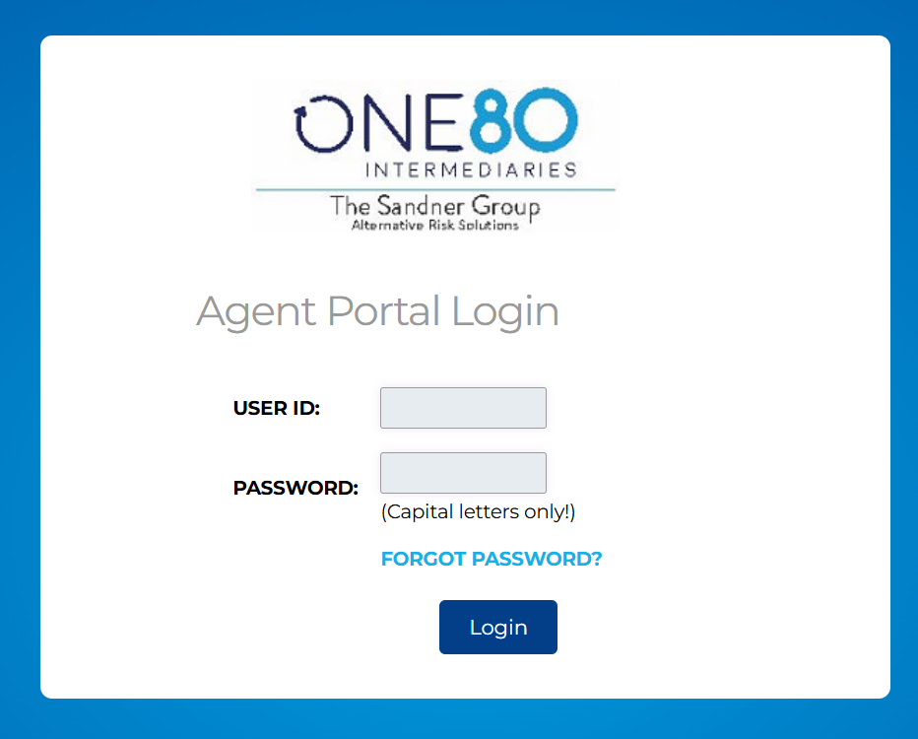
Multi-Factor Authentication Enhancement
After logging in with your User ID and password, a New Multi-Factor Web Page will be Displayed

Multi-Factor Authentication Web Page
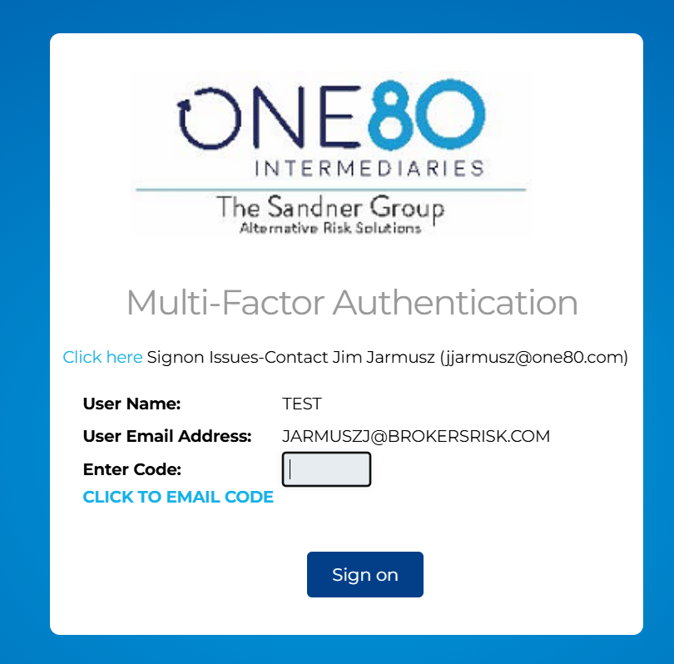
- CLICK TO EMAIL CODE (A 6-digit Code will be sent to the User’s Email Address)
- The Code will expire in 10 Minutes
- Enter 6 digit code and click Sign on submission button. If successful, access is allowed to the Agent Portal.

If Username or Email Address is not correct, The User Profile will need to be updated
Click here Sign on Issues- Contact Jim Jarmusz (jjarmusz@one80.com)

